**Aidan Brown**

**GEOG 501 Fall 2023**

**Part A**

# Deliverable 1

Find all the store / shopping center parcels on East Fowler Ave in the city of Tampa. How many parcels are there?

3

Total parcels on East Fowler Ave in Tampa.

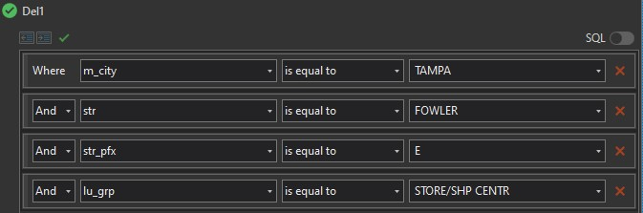

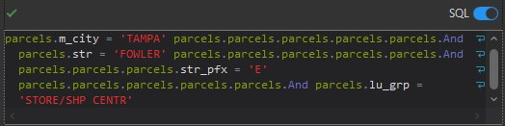

# Deliverable 2

Find all the vacant commercial parcels that are larger than 0.5 acres with a total land value of less than $100,000. How many parcels are there meeting these criteria?

9 total parcels meet this criteria.

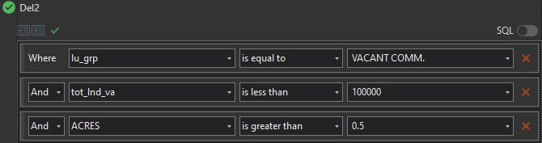

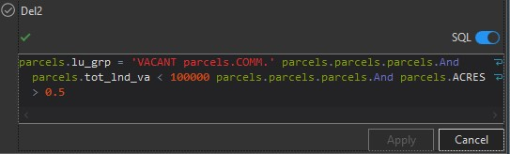

# Deliverable 3

Find all the vacant properties (of any type) located in city of Temple Terrace? How many parcels are there?

111

vacant property parcels.

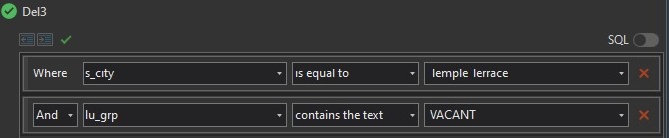

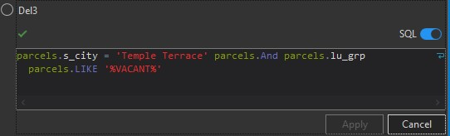

# Deliverable 4

238

parcels are affected by the flooding.

Total value is $39,270,004.

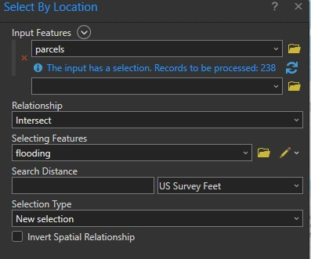

# Deliverable 5

29

total parcels are completely covered by the flooding.

The total building value is $3,128,254.

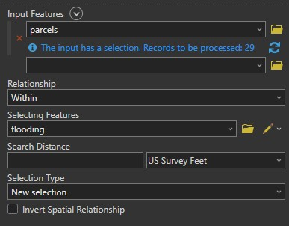

# Deliverable 6

Using the 'Have their center in' option gives a total of 97 buildings.

The total building value is $8,917,356.

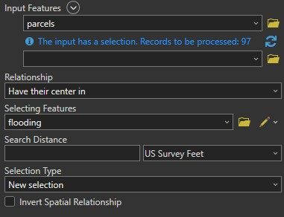

# Deliverable 7

12

total parcels are within 1 mile of the flood zone.

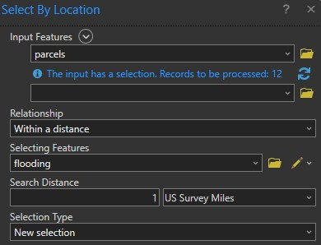

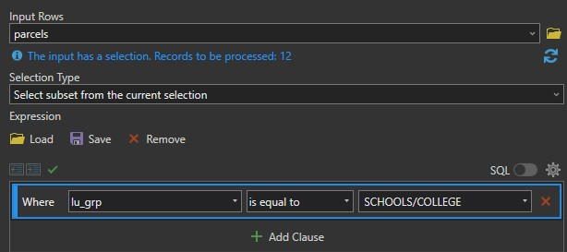

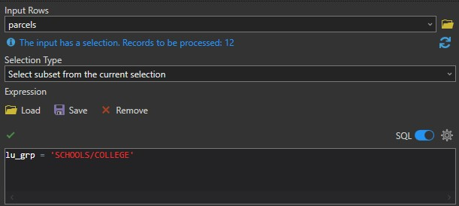

**Part B**

# Deliverable 8

I used STFID and KEYLOCK fields to join the tables as they have a many to many relationship.

# Deliverable 9

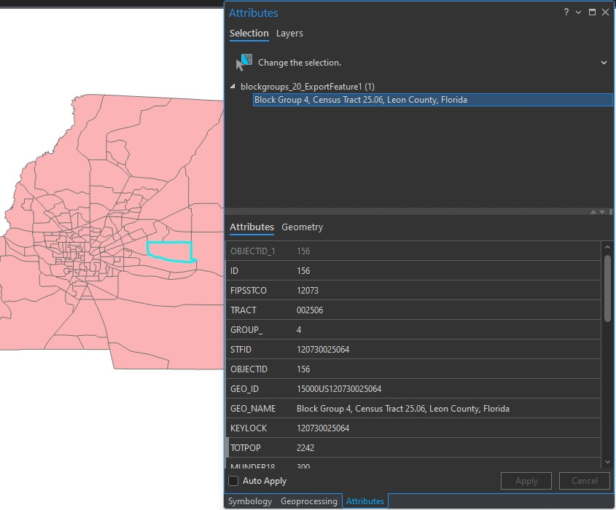

# Deliverable 10

Using the ZONING field in the **zoning** table to join with the ZONING field in the **zoning_codes** table has a cardinality of 1 to 1.

# Deliverable 11

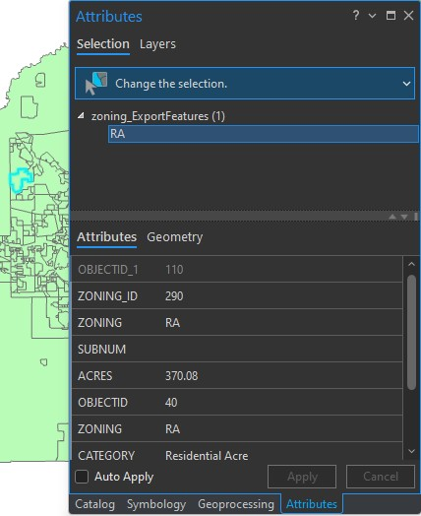

# Deliverable 12

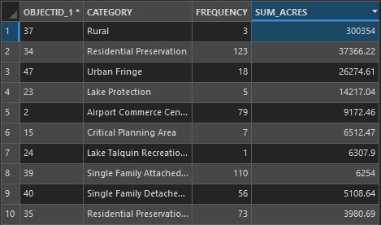

# Deliverable 13

Maximum bus route is the Venom Express, the route length is 25289.

Average bus length is 6646.